**Batch: B2 Roll No.: 1611099**

**Experiment / assignment / tutorial No. 4**

**Grade: AA / AB / BB / BC / CC / CD /DD**

**Signature of the Staff In-charge with date**

|  |
| --- |
| **Batch: B2 Roll No.: 1611099 Experiment / Assignment / Tutorial No.: 4** |

|  |
| --- |
| **Title: Installation & configuration of Web Server.** |

**Objective:**

1. To install & configure Apache2 web server on Ubuntu.
2. To understand the functioning of a webserver.

**____________________________________________________________________**

**Expected Outcome of Experiment:**

1. Manage the configurations by using network administration tools.

**___________________________________________________________________________**

**Books/ Journals/ Websites referred:**

1. Linux Lab - Open source Technology : Ambavade –Dreamtech.
2. https://help.ubuntu.com/lts/serverguide/serverguide.pdf

**____________________________________________________________________________**

**Pre Lab/ Prior Concepts:**

Web server, packages for web server, web technologies, operating system, Computer network, systems lab etc.

______________________________________________________________________________

**New Concepts to be learned:**  Apache2 configuration, different Apache2 files & commands, HTTPD, Virtual hosting, Name based hosting, IP based hosting, Directives.

**Introduction:**

The Apache HTTP Web Sever (Apache) is an open source web application for deploying web servers. Apache is the most commonly used Web server on Linux systems. Web servers are used to serve Web pages requested by client computers. Clients typically request and view Web pages using Web browser applications such as Firefox, Opera, Chromium, or Internet Explorer. Users enter a Uniform Resource Locator (URL) to point to a Web server by means of its Fully Qualified Domain Name (FQDN) and a path to the required resource.

The most common protocol used to transfer Web pages is the Hyper Text Transfer Protocol (HTTP). Protocols such as Hyper Text Transfer Protocol over Secure Sockets Layer (HTTPS), and File Transfer Protocol (FTP), a protocol for uploading and downloading files, are also supported.

**Implementation details:**

A). IP Based hosting – Part 1

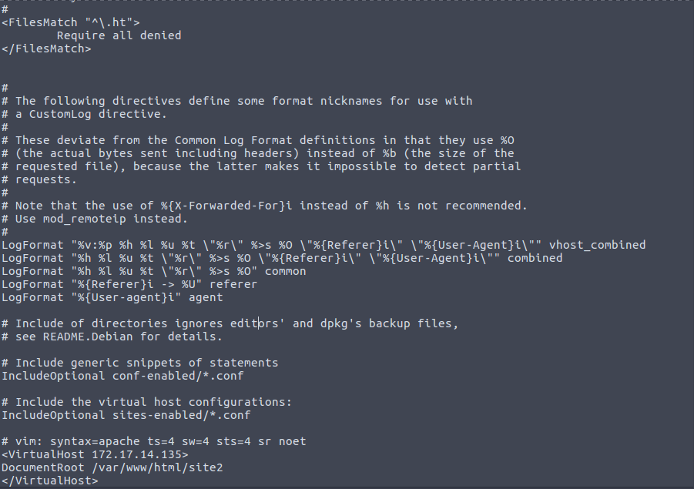

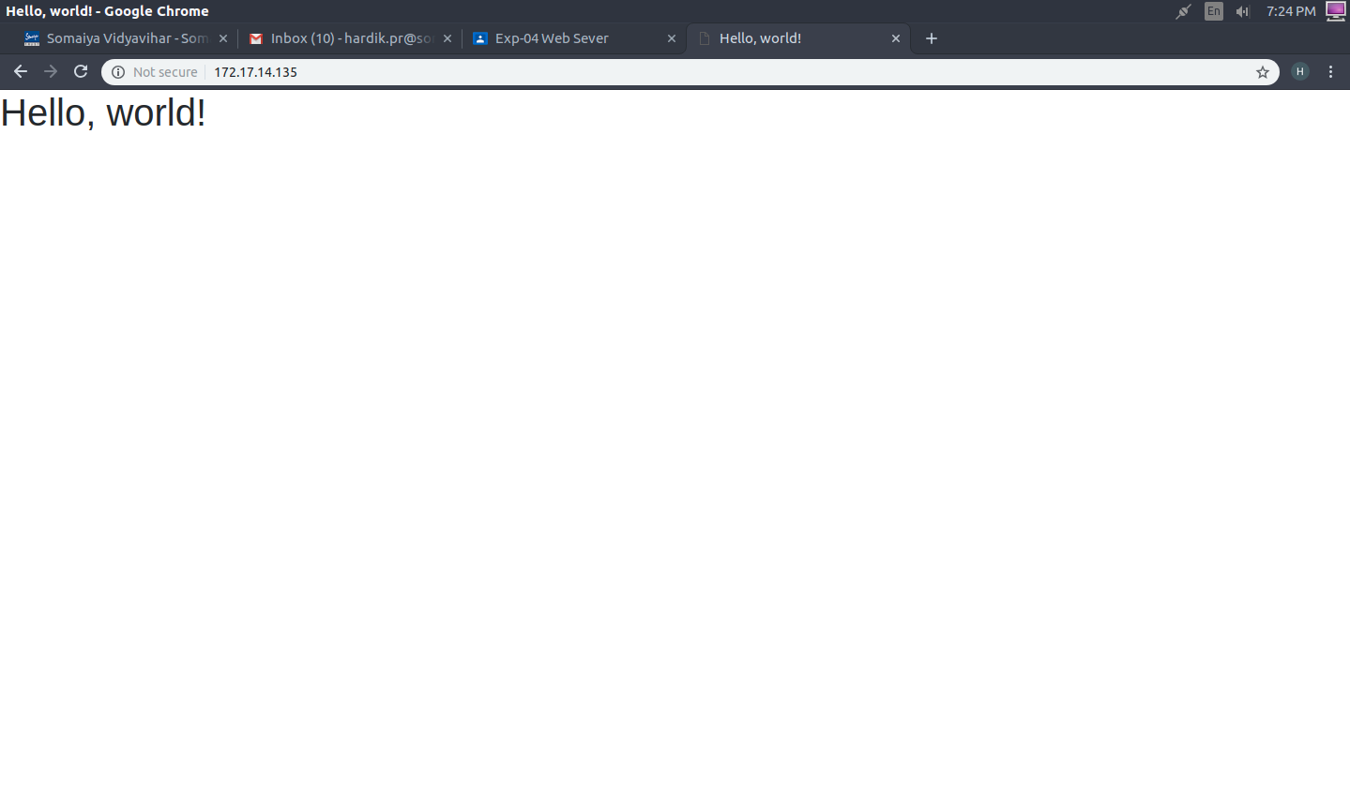

IP Based hosting - Part 2

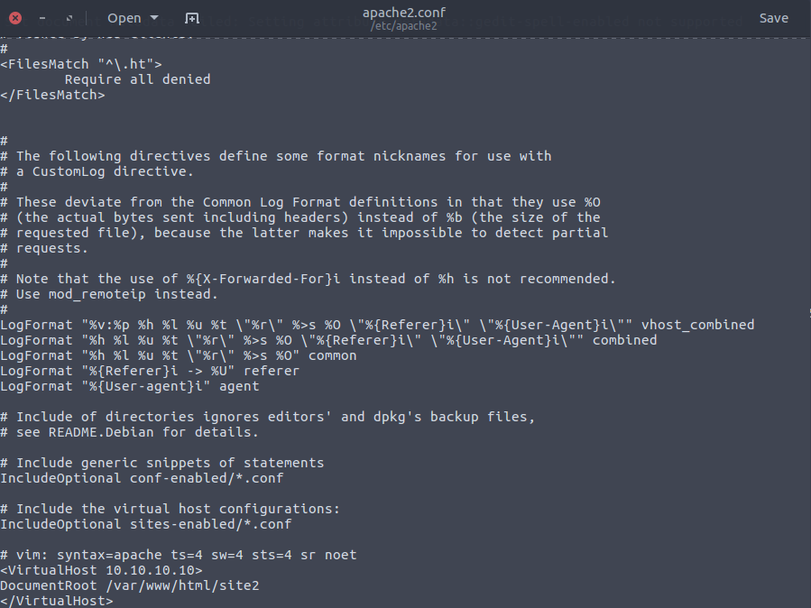

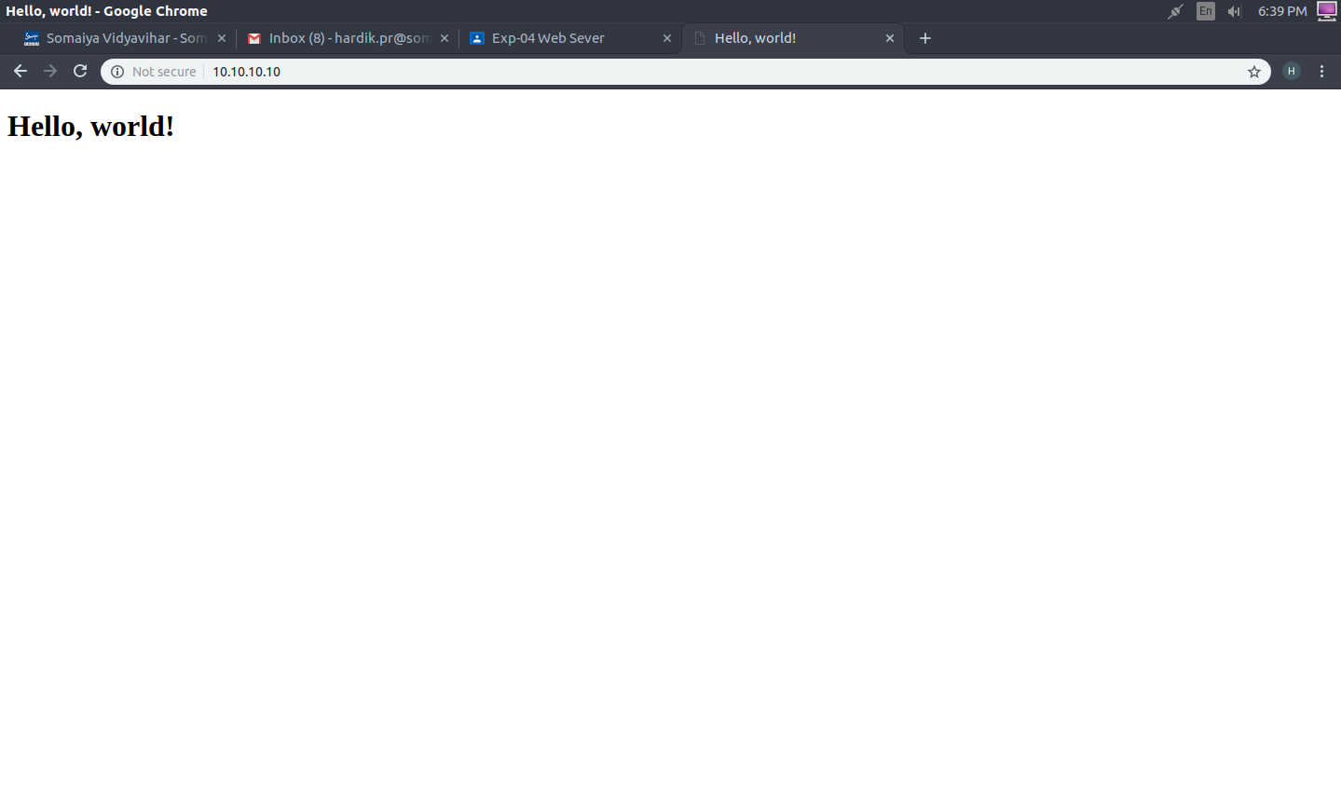

**B). Name Based hosting – Part 1**

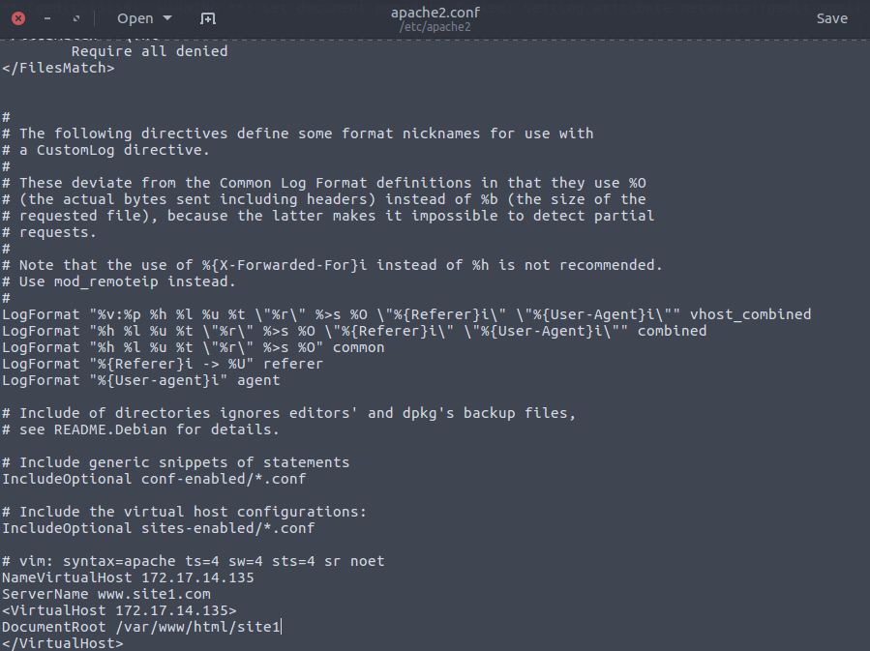

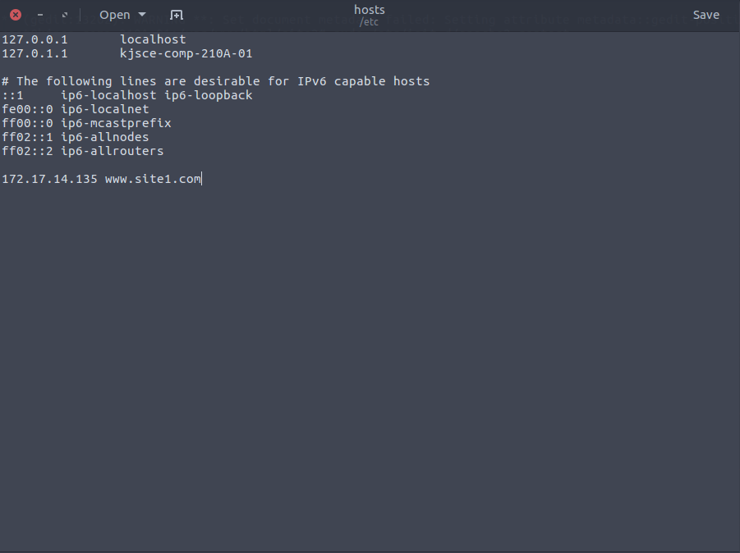

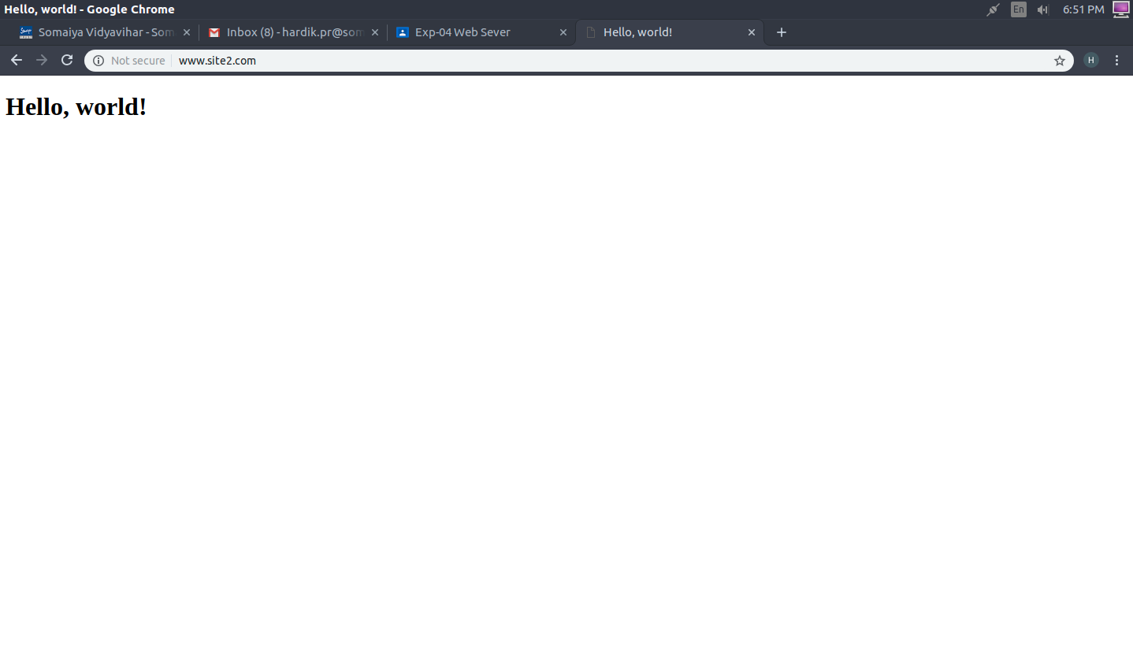

**Name Based hosting - Part 2**

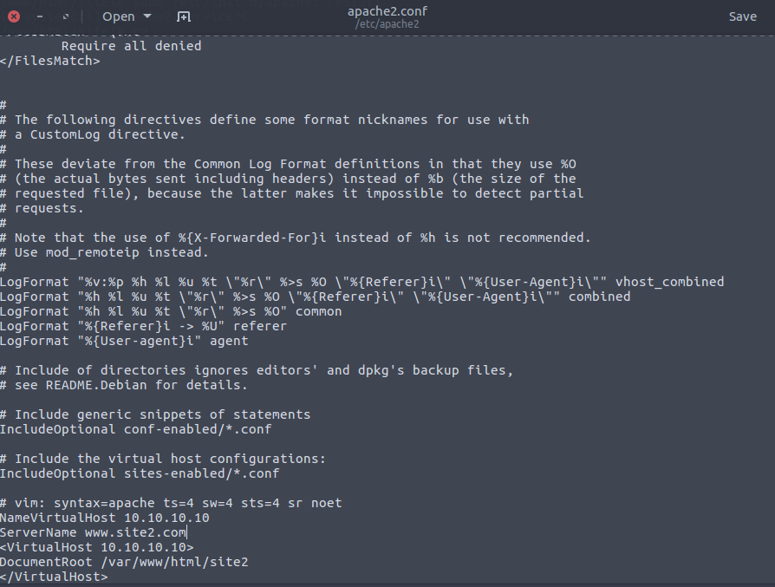

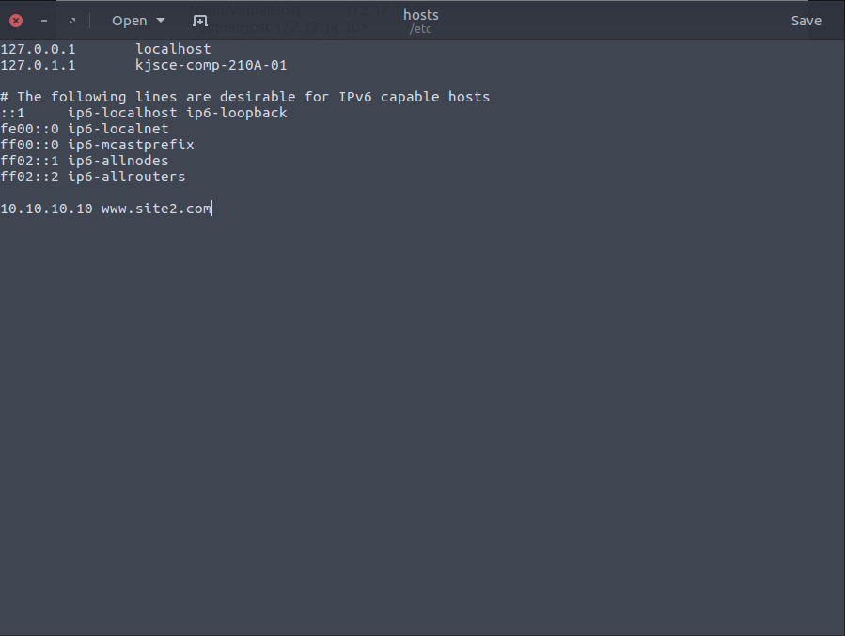



**Broadcast:**

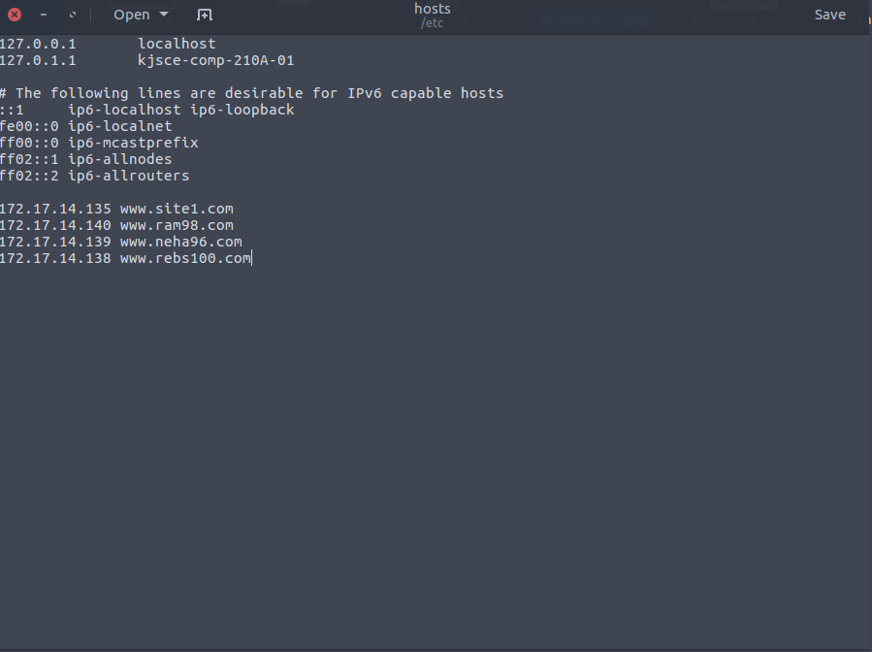

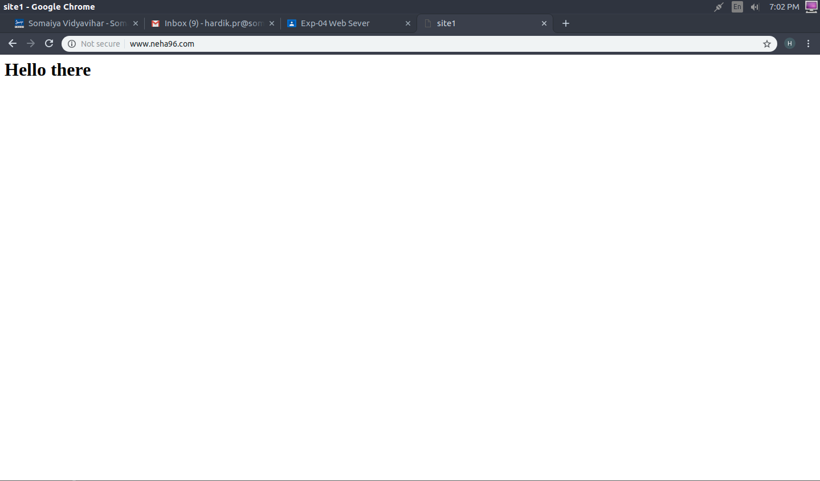

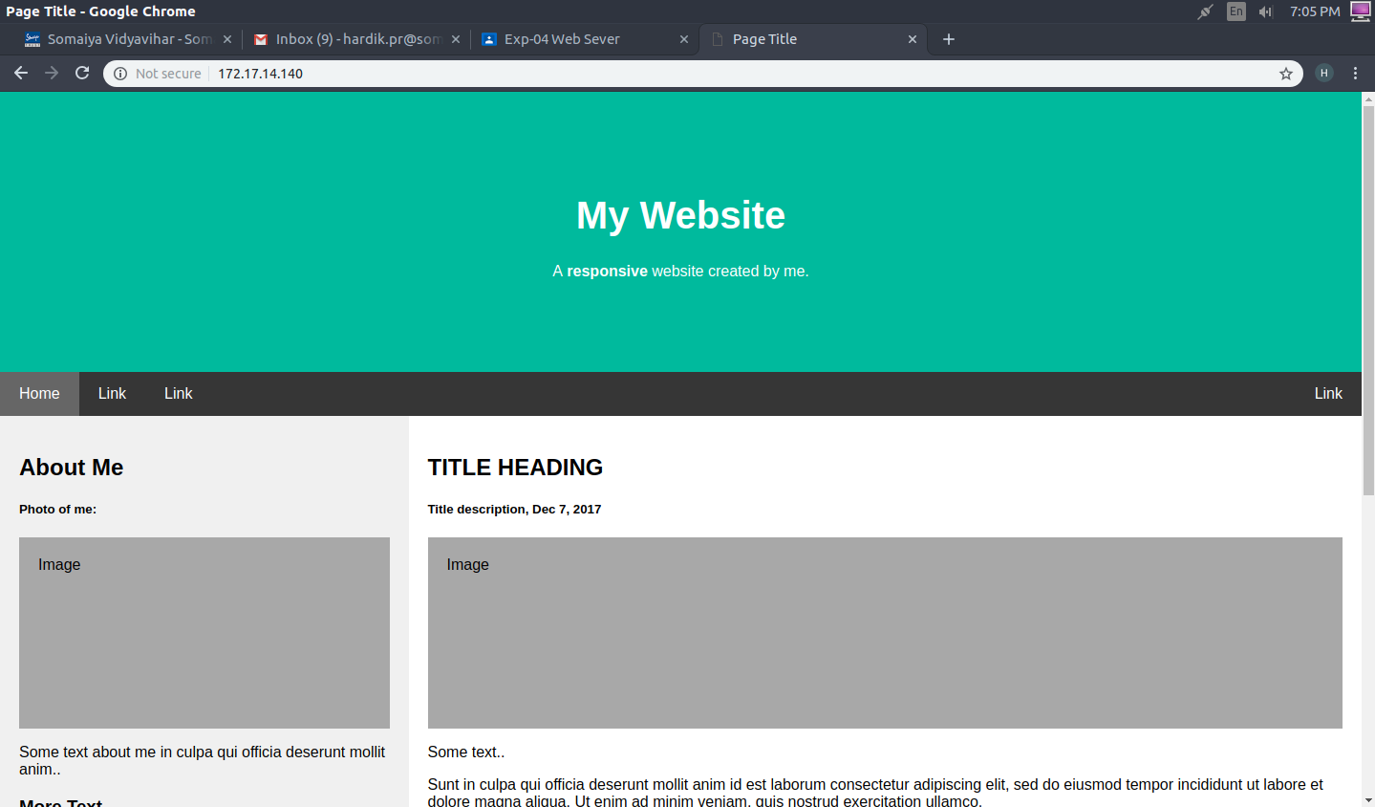

**Conclusion:** Thus, we have understood the working of Web Server and also installed and configured Web Server based on IP address and domain names.